ISSUES : FIGURE SET
Patterns and process in Landscape Ecology: Physical template, biotic interactions, and disturbance regime

Cari Ficken^{1,3}, Megan Fork², and Matthew Fuller²

¹University Program in Ecology, Duke University
²Nicholas School of the Environment, Duke University
³Corresponding Author: Cari Ficken (cari.ficken@duke.edu)

THE ISSUE
Ecological processes and patterns interact at various scales across landscapes. Spatially explicit consideration of pattern and process can better inform ecological questions. This Figure Set introduces students to the variability in scales of pattern and process and to the fundamentals of Landscape Ecology.

ECOLOGICAL CONTENT
allelopathy, biotic and abiotic interactions, competition, disturbance regime, fire regime, landscape ecology, physical template

STUDENT-ACTIVE APPROACHES
Think-pair-share, sketching conceptual figures

STUDENT ASSESSMENTS
sharing sketches of conceptual figures with class, informal short answer synthesis and application questions

ACKNOWLEDGEMENTS
We would like to thank Dean Urban for his initial encouragement to develop this teaching module, as well as comments on previous drafts. We also thank two anonymous reviewers for their helpful feedback and suggestions to improve the Figure Set. In addition, we thank Justin Wright for allowing us to trial our teaching module with his undergraduate ecology class.

OVERVIEW

WHAT IS THE ECOLOGICAL ISSUE?
Landscape Ecology seeks to understand the interactions between ecological patterns and processes across varying spatial scales (Turner 2005). In some landscapes, extreme gradients drive patterns through their effect on physical processes. For example, the large elevation gradients in mountainous landscapes influence temperature and moisture, thereby causing plant species to sort into communities along the gradient according to their ability to grow and compete at different temperatures and soil moistures. However, subtle gradients also occur frequently in nature and can similarly influence variation in the physical and ecological variables that influence landscape pattern. To appreciate variability in the spatial scales of patterns and processes, this introductory lesson in Landscape Ecology compares two landscapes with large and small elevation gradients.

FIGURE SET TABLE

Figure Set and  Ecological Question | Student-active Approach | Cognitive Skill | Class Size/Time
This figure set introduces the field of Landscape Ecology by asking students: How do ecological processes and landscape patterns interact? Three sections ask students to examine how three types of drivers influence landscape pattern: the physical template, biotic interactions, and disturbance regimes. Using the Sierra Nevada Mountains and the Florida Scrub as examples, students explore how landscape patterns and ecological processes interact. | Think-Pair-Share | Comprehension, application, synthesis | Class size: Small  Time: Moderate (time requirements include reading to be completed before class, an activity designed to take one 50 minute class period, and possibly a short follow-up as homework)

FIGURE SET BACKGROUND

This figure set is intended for undergraduate students nearing the end of an introductory ecology course. The reading and exercises draw on ecological concepts students should already know; the synthesis and application of these concepts are discussed in new ways to give a spatially explicit context to understanding ecology. A glossary is supplied in the materials for students to clarify and refresh any terminology. In this Figure Set, we use the Sierra Nevada Mountains and the Florida Scrub as examples to illustrate the variability in scale of pattern and process in landscapes.

Study Areas

The Sierra Nevada mountain range runs 640 km along a north-south axis in California and Nevada and has topography spanning thousands of meters. This large elevation gradient drives climatic conditions by creating predictable variation in temperature and moisture between low and high elevations. These changes in environmental conditions (driven by elevation gradients) lead to patterns of vegetation composition. Large trees are the dominant vegetation of the Sierra Nevada, and different plant communities in this region are usually defined by their dominant tree species. Based on their physiological ability to produce biomass and reproduce at the temperature and moisture conditions at a given elevation, different plant communities exist in horizontal bands along mountainsides.

However, the environmental conditions in which a plant could exist (fundamental niche) likely differ from the conditions in which they actually exist (realized niche). Competitive interactions between species play a role in the vegetation pattern of this landscape. Highly competitive species under given environmental conditions will exclude less competitive species, displacing them to other habitats within the landscape. Species such as incense cedar (Calocedrus decurrens) and Ponderosa pine (Pinus ponderosa) are more drought resistant than other Sierra Nevada species (Urban et al. 2000), and therefore dominate the vegetation community in dry habitats. In contrast, colder areas at higher elevations in the mountains are occupied by vegetation communities that include Western white pine (Pinus monticola) and Lodgepole pine (Pinus contorta), which are resistant to lower average temperature (Urban et al. 2000).

In contrast to the large elevation gradients of the Sierra Nevada, elevation in the Florida Scrub varies on the order of only tens of meters (Boughton et al. 2006). The Florida Scrub is located along the Lake Wales Ridge, a two million year old relic dune which runs approximately 240 km north to south down the center of the Florida peninsula (Weekley et al. 2008). The sandy soils of the Florida Scrub are xeric and retain little water despite receiving on average 136 cm of precipitation annually (Menges and Hawkes 1998, Lohrer 2008). The landscape pattern within Florida Scrub can be described at many scales: at a larger extent, seasonal wetlands (on the order of 2,000 m2 in area) exist in low-lying depressions, embedded within a matrix of scrubby vegetation (Ficken and Menges 2013). At a smaller extent, within the scrubby vegetation matrix, patches of different plant communities contrast with bare sand gaps. Rosemary scrub exists on knolls with a particularly high cover of bare sand and Florida rosemary (Ceratiola ericoides), an allelopathic shrub.

FIGURES

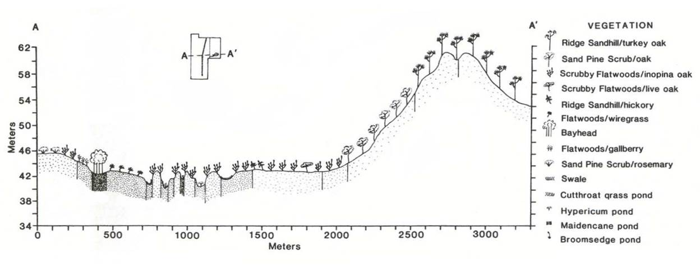
Figure 1. A transect through the Florida Scrub within Archbold Biological Station. This transects runs approximately 3,300 m from east to west and spans a small range of elevations. Vegetation types are shown in the legend. Plant symbols illustrate differing vegetation communities found on the Florida Scrub landscape. In this landscape, the vegetation sorts primarily according to soil moisture, allelopathy, and disturbance regime. Adapted from Abrahamson, W. G., A. F. Johnson, J. N. Layne, and P. A. Peroni. 1984. Vegetation of Archbold Biological Station, Florida: An example of the southern Lake Wales Ridge. Florida Scientist 47:209–250.
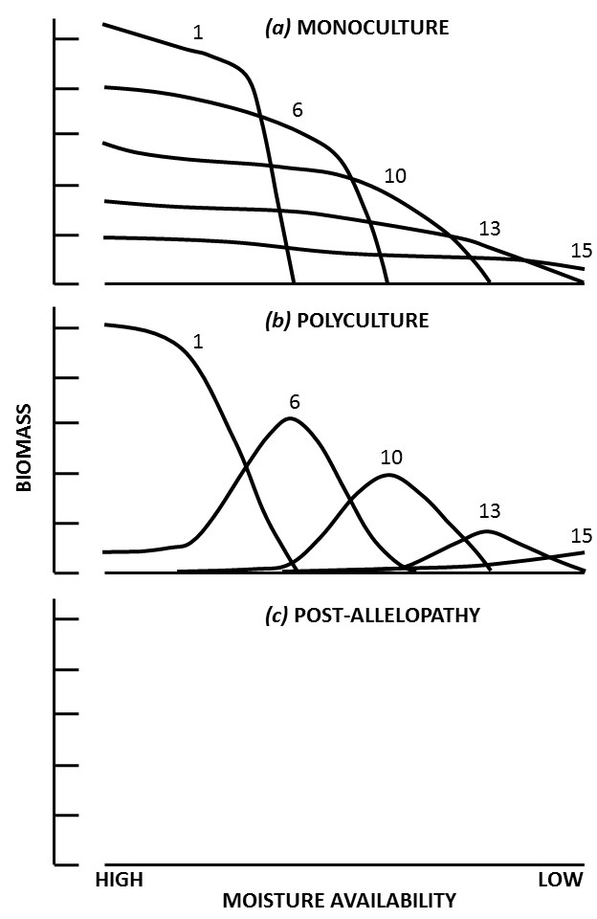
Figure 2. Patterns of plant biomass along a moisture gradient. (a) Five functional types grown in monoculture all produce more biomass with higher moisture availability, but have variable abilities to produce biomass at low moisture availability. (b) After introducing competition among the five different species, vegetative sorting occurs due to competitive exclusion and the ecological optima (model peaks) are shown for each species indicating the location along the moisture gradient where that functional type would outcompete the others and therefore be present with the highest biomass. Note how species 1 outcompetes most other species at high moisture availability, whereas species 15 outcompetes most other species at low moisture availability. (c) Blank for student completion. Figure modified from Smith, T. and M. Huston. 1989. A theory of the spatial and temporal dynamics of plant communities. Plant Ecology 83:49-69.
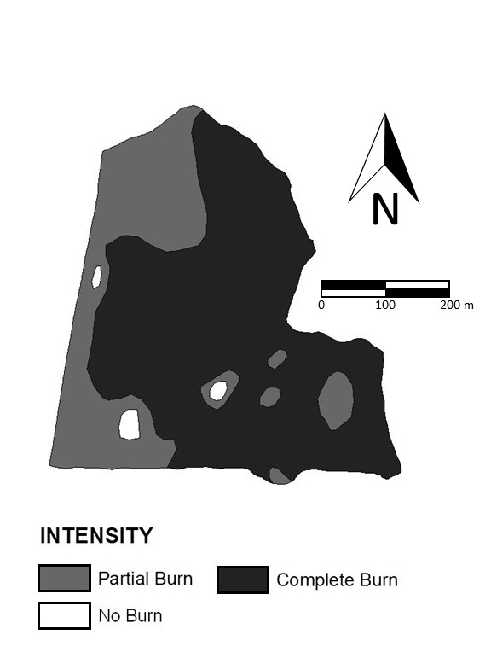
Figure 3. Map of fire intensity of a prescribed burn at Archbold Biological Station. Figure from Main, K. 2010. Land Management: Preserving and Restoring Biodiversity. Archbold Biological Station. Retrieved 8/16/2013 from http://www.archbold-station.org/station/html/land/lmovr.html © 2010 Archbold Biological Station
Copyrights have been secured for use of these figures in the context of publication in TIEE; please see copyright agreement

PRE-CLASS READING AND ACTIVITY

Overview

What Is the Ecological Issue?
Landscape Ecology seeks to understand the reciprocal interactions between ecological patterns and processes across varying spatial scales (Turner 2005). In some landscapes, extreme gradients drive patterns through their effect on physical processes. For example, the large elevation gradients in mountainous landscapes influence temperature and moisture, and thus influence the locations of appropriate habitats for different plants within the landscape. However, subtle gradients also occur frequently in nature and can similarly influence variation in the physical and ecological variables that help create landscape pattern. To appreciate variability in the spatial scales of patterns and processes, this introductory lesson in Landscape Ecology compares two landscapes with large and small gradients. This exercise should broaden your understanding of which processes form patterns in landscapes, how they do so, and how pattern influences processes. You will draw on ecological concepts you should have already learned, synthesize them, and apply them in new ways to give you a spatially explicit context to understand Ecology.
Scale, grain, and extent of landscape pattern

When we study landscape pattern, our data are characterized by its grain and spatial extent. The grain is the resolution of the data (i.e. smallest area of measurement). For example, the grain might be a 0.25 m2 quadrat in a detailed plant survey, or 100 km2 in a study using satellite images. The spatial extent refers to the total area occupied by the dataset. In the detailed plant survey mentioned above, the extent of the data might be a few hectares of abandoned farm field; for a study that uses satellite images to study land cover change, the extent might be a continent or ecoregion. Together, the grain and extent of a dataset make up the scale of the data. It is important to match the scale of the data to the pattern that you wish to study. Too coarse a grain will miss the important elements of the pattern, while too small an extent may not capture enough of the pattern of interest to be able to analyze it. In other words, a pattern may only become apparent at a scale appropriate to its observation.
Within a landscape, patterns can occur at many scales and be nested within each other. It is important to understand how patterns nest within each other to appreciate the limits of any one observation. For example, there may be pattern in landscaping around a single home (the extent is the property unit) consisting of patches of different flowers, bushes, and grass (the grain at this scale might be approximately 1 m²). Zooming out to the larger extent of the neighborhood, you may observe a pattern made up of several property units. At this scale, the property unit becomes the grain size. Furthermore, zooming out even further to the extent of a sprawling city may show a pattern of different neighborhoods. At this largest scale, individual neighborhoods might become the grain appropriate for the observed patterns. Within the neighborhoods, there are nested patterns of individual yards. Thus, choosing a scale that is best for an analysis depends on the research question. Furthermore, the spatial scale of a pattern is closely linked to the temporal scales of associated processes (see Figure 2.1 in Turner 2001). Back to our example of neighborhood yards, a gardener can influence the pattern within his or her yard in a single afternoon. In contrast, changes in development patterns at the scale of a whole city would take years or decades.

In this exercise, we will consider how vegetation patterns and ecological processes at different scales can function in similar or different ways. At each scale, there are many biotic and abiotic patterns to discuss, but we will focus primarily on three main drivers of vegetation patterns and some of their consequences. First, physical differences (e.g., temperature and moisture differences driven by geology and geomorphology) among parts of the landscape make conditions more or less optimal for certain plant species to grow (the physical template). In addition to the physical template of the landscape, biotic interactions among plants further influence the vegetation pattern. Finally, the disturbance regime contributes to the pattern of vegetation on the landscape. Importantly, the interaction between ecological process and landscape pattern is not unidirectional as vegetation patterns themselves shape the ecological processes on the landscape.

Study Areas
The Sierra Nevada mountain range runs 640 km along a north-south axis in California and Nevada and has topography spanning thousands of meters. This large elevation gradient drives climatic conditions by creating predictable variation in temperature and moisture between low and high elevations. These changes in environmental conditions (driven by elevation gradients) lead to patterns of vegetation composition. Large trees are the dominant vegetation of the Sierra Nevada, and different plant communities in this region are usually defined by their dominant tree species. Based on their physiological ability to produce biomass and reproduce at the temperature and moisture conditions at a given elevation, different plant communities exist in horizontal bands along mountainsides.

However, the environmental conditions in which a plant could exist (fundamental niche) likely differ from those conditions in which they actually exist (realized niche). Competitive interactions between species play a role in the vegetation pattern of this landscape. Highly competitive species under the given environmental conditions will exclude other, less competitive species, displacing them to other habitats within the landscape. Species such as incense cedar (Calocedrus decurrens) and Ponderosa pine (Pinus ponderosa) are more drought resistant than other Sierra Nevada species (Urban et al. 2000), and therefore dominate the vegetation community in dry habitats. In contrast, the colder areas in the mountains are occupied by vegetation communities that include Western white pine (Pinus monticola) and Lodgepole pine (Pinus contorta), which are resistant to lower average temperatures (Urban et al. 2000).
In contrast to the large elevation gradients of the Sierra Nevada, elevation in the Florida Scrub varies on the order of only tens of meters (Boughton et al. 2006). The Florida Scrub is located along the Lake Wales Ridge, a two million year old relic dune which runs approximately 240 km north to south down the center of the Florida peninsula (Weekley et al. 2007). The sandy soils of the Florida Scrub are xeric and retain little water despite receiving on average 136 cm of precipitation annually (Menges and Hawkes 1998, Lohrer 2007). The landscape pattern within Florida Scrub can be described at many scales: at a larger extent, seasonal wetlands (on the order of 2,000 m2 in area) exist in low-lying depressions, embedded within a matrix of scrubby vegetation (Ficken and Menges 2013). At a smaller extent, within the scrubby vegetation matrix, patches of different plant communities contrast with bare sand gaps. Rosemary scrub exists on knolls with particularly high cover of bare sand and Florida rosemary (Ceratiola ericoides), an allelopathic shrub.

Background Information

Landscape pattern and the physical template
The locations of different plant communities within a landscape are determined in part by physical differences among areas within the landscape. These physical differences include temperature, soil moisture, light availability, and exposure to wind, and are collectively referred to as the physical template. Because plants differ in their physiological ability to persist under different physical conditions (e.g., drought or wind exposure) and have different resource requirements (e.g., sunlight or soil moisture), the physical template is one of the three main drivers of vegetation patterns on a landscape.

In the following activity, you will contrast the role of the physical template on landscape pattern in two different landscapes. First, consider the physical template on a mountainside. If you have hiked in the mountains, you may have noticed that the climate changes as you go up in elevation (it becomes colder and wetter as you ascend). Temperature decreases as you rise in elevation because the air pressure is lower at higher altitude. This phenomenon is called adiabatic cooling and can be approximated by a 10°C temperature decline for every 1,000 m rise in elevation (adiabatic lapse rate) for dry air. As increasing elevation drives decreases in temperature, water condenses and the climate becomes wetter. Differences in elevation therefore primarily influence water availability and temperature, and vegetation sorts according to its ability to persist under these conditions. This means that species with a greater ability to persist in cold conditions can exist at higher elevations, and drought-resistant species can exist on the drier, lower slopes of the mountain. How does this result in patterns in mountainous landscapes? Plant species with similar physiological requirements for resources or resistance to stressful conditions form horizontal bands of community types at different elevations along a mountainside.
In contrast to mountainsides, the Florida Scrub is a landscape with very little topography. Here, small changes in the physical template (1-2 meter elevation change, termed microelevation) influence the patterning of scrub landscapes (Boughton et al. 2006). At this scale, the physical template still drives vegetation patterns by influencing water availability, but it does so through the distance to the water table. Thus, microelevation, too, results in plants sorting according to their ability to withstand drought and inundation. However, the relationship between water availability in the two example landscapes is reversed, with microelevation being wetter at low elevations and mountainous landscapes wetter at high elevations.

Landscape pattern and biotic interactions
Biotic interactions manifest in pattern across landscapes via many forms of biotic processes. Species demography, competitive interactions, predation, and dispersal are just some of the ways biotic interactions among species drive pattern in a landscape. Our two focal landscapes share several types of biotic interactions, but this exercise will focus on two: competitive interactions and allelopathy. Plants require many different resources (water, light, nutrients, etc.) to survive, and specific requirements differ by species. Species can usually tolerate some range of resource availability, but may have peak growth rates at some optimum level of resource availability. When two species have resource needs that overlap, competition for that resource ensues. If one species is a better competitor for the limiting resource, species that are less efficient at acquiring it are pushed out of the range of optimal resource availability, but within the range of their acceptable resource availability. This type of competitive interaction is called competitive exclusion. Competitive interactions are thus a primary driver of vegetation zonation on mountain slopes and other landscapes.
The Florida Scrub also demonstrates vegetative sorting from resource competition, but includes the additional biotic interaction of allelopathy. Allelopathic plants generate compounds that actively interfere with the growth or survival of other species around them. Allelopathic compounds may even prevent other species from germinating (Richardson and Williamson 1988)! These compounds help allelopathic species maintain a buffer space around them, and thus reduce competition for the resources they require for optimal growth. In the Florida Scrub, Florida rosemary (Ceratiola ericoides) generates allelopathic compounds from its leaf litter as well as through root exudates (Hunter and Menges 2002). The result of this biotic process is a patchy landscape consisting of bare sand and Florida rosemary bushes.

Landscape pattern and disturbance regime
The final process that can drive landscape pattern is known as the disturbance regime. In the Florida Scrub, although the summers come with heavy rains, the soils are well-drained and dry, so species must be adapted to both drought and flood conditions. Here, we will focus on patterns and processes influenced by the regular fire disturbances that occur during dry conditions. Fires in the Florida Scrub are extremely patchy, and depend on fuel accumulation (which itself depends on the litter production of the vegetation community. Communities that generate lots of litter have more fuel for fires to burn) and soil moisture. Fires consume plant litter as fuel, and intense fires remove resources from the area. Conversely, mild or moderate fires may only partially consume fuel stores, accelerating fuel breakdown and increasing nutrient availability immediately after a fire. Across the landscape, soil moisture and fuel availability vary at small spatial scales and therefore the frequency and intensity of fires are highly variable.

In addition to the physical template and biotic interactions, vegetation in the Florida Scrub sorts based on life history responses to fire disturbances. This results in distinct patterns of plant communities that utilize similar post-fire response strategies and a given fire return interval (FRI). In this way, the disturbance regime influences vegetation patterns, and the vegetation patterns also influence the disturbance regime. Remember, though, that disturbance regime is only one driver of vegetation patterns across landscapes. As such, an understanding of the disturbance regime does not guarantee an identification of the vegetation community. For example, Rosemary scrub at high microelevations burns infrequently because the allelopathic chemicals produced by the dominant plant limits vegetation growth and fuel accumulates very slowly (there is nothing for a fire to burn; see Landscape pattern and biotic interactions section).

However, wetlands in the Florida Scrub (called hammocks) also rarely burn, but because they are at lower microelevational positions and therefore wetter. Like Rosemary scrub, sandhills are also found at high microelevations, but burn frequently because they are composed of resprouting species that produce fuel quickly after a burn. At intermediate microelevations, we find communities such as scrubby flatwoods that experience patchy fires regularly. These communities include species that can resprout from their unburnt belowground biomass after a fire, and thus quickly produce litter and fuel. Such species not only promote fire, but also have a competitive advantage in areas that burn frequently. In comparison, species that reproduce through seeds are more common in habitats that burn less frequently (Menges and Hawkes 1998). After a fire in the Florida Scrub, woody species tend to resprout whereas herbaceous species tend to put out seed.

Menges and Hawkes (1998) examined the importance of fire disturbances for maintaining native plant communities in the Florida Scrub. They explained that disturbance regimes encourage the persistence of diverse plant communities by influencing each species differently. Importantly, they examined how fire disturbance variably affected communities depending on their local environment. They found that xeric Rosemary scrub had more specialized species that reseeded after a fire than the less-xeric scrubby flatwoods that burn more often. Open patches of bare sand close more quickly after fire in scrubby flatwoods (because the vegetation is dominated by resprouting species), so more herbaceous, pioneer, and endemic species are found in Rosemary scrub.

Pre-class activity
Use this activity to think about how the spatial scale of analysis must be matched to the scale of the pattern and process for some example research questions. Before coming to class, look up your hometown on Google Earth (http://www.google.com/earth/). Within Google Earth, zoom to scales that would be appropriate to answer each of the following questions:

1) Zoom to a spatial extent where you can see both the center of the closest town or city and the surrounding rural area. Estimate the total area that is now visible on your screen (use the scale bar). This area is the extent of your view.
2) Decrease your extent by an order of magnitude (i.e. zoom in until you see about 10% of your original spatial extent). Pan around the landscape at this new extent. What different patterns can you now observe in the landscape?
3) Now, increase the extent of your view by an order of magnitude from your original view (i.e. 10x the area should be visible as compared to your view in part 1). Pan around the landscape at this new extent. What new patterns can you observe at this extent?

Please bring screenshots of your landscape at the appropriate scale for each question to class (these will not be turned in, but you will use them to discuss scale in class). Be prepared to discuss the patterns you have identified and to compare the scales you used with others.

PART 2 - IN-CLASS ACTIVITY

Landscape pattern and the physical template
Instructions:
In the second part of the activity, you will use what you have learned about how the physical template shapes vegetation pattern on mountainsides to think about pattern in a different landscape. In completing this activity, you should take the concepts from the reading and apply general principles of Ecology to explain how patterns form in a variety of landscapes.

Turn to a neighbor and discuss Figure 1, which depicts vegetation pattern and elevation gradients along a transect in the Florida Scrub. Note that the scale of variation in the elevation of the Florida Scrub landscape is much smaller than in mountainous landscapes (in fact, these relatively small differences in elevation are not enough to drive the same kinds of weather patterns in large mountains).

On the figure above, indicate where you would find the following plants:

Plant A: High drought resistance and low resistance to water-logged soil
Plant B: Medium resistance to both drought and water-logged soil
Plant C: Low drought resistance and high resistance to water-logged soil

Note that Figure 1 illustrates a profile of Archbold Biological Station in the Florida Scrub landscape, and that the y-axis ranges only a few 10’s of meters. Next, imagine an increase in the range of the y-axis so that it approximates the elevation change of a mountainous landscape.

1) Indicate where plants A-C would be found in a mountainous landscape.

2) Why do their positions change? (Hint: Think about the role of the physical template in structuring soil moisture in the two landscapes.)

Landscape pattern and biotic interactions

Instructions:
The previous activity prepared you for understanding how physical differences (e.g., water availability) among places in the landscape create gradients in resources and stressors. Plants sort themselves based on such gradients according to their ability to outcompete other species for resources (Figure 2) and resist stressors. Smith and Huston (1989) used model simulations of different plant functional types (groups of plant types that have similar resource requirements and resistance to stressful conditions) to predict where different types of plants sort along resource gradients.

Remember from the background information that allelopathic plants generate chemicals that inhibit the growth and survival of competitors in their general vicinity (Richardson and Williamson 1988). An allelopathic plant decreases competition for local resources by reducing the number of adjacent species and is therefore able to access the resources that other species would consume.

Figure 2 shows the biomass of different plant species (identified by numbers) along a gradient from high to low moisture. The top panel shows the biomass curves for each plant grown by itself (monoculture) and the middle panel shows the biomass curves when the plants are grown together (in polyculture). Work with your partner to answer the following questions:

- Notice that the level of soil moisture associated with peak biomass accumulation changes for all species as they move from a monoculture to a polyculture. Explain why we observe this pattern.

- Now, imagine functional type 10 (Figure 2) gains the ability to produce allelopathic chemicals (all other plant traits for functional type 10 remained the same though).
  - How does allelopathy influence the ability of functional type 10 to produce biomass at high soil moisture levels in monoculture?
  - At low soil moisture levels in monoculture?
  - How does allelopathy influence the biotic interactions between functional type 10 and the other functional types (in polyculture)?

- In Figure 2c, sketch your predictions of the patterns of biomass production for all five functional types after type 10 has developed allelopathy. Be prepared to explain your reasoning.

Landscape pattern and disturbance regime

Instructions:

When completing the following section, keep in mind that the Florida Scrub landscape is very patchy. In addition to disturbance regimes, the physical template and biotic processes result in very different vegetation communities existing in close proximity to one another. As mentioned above, different vegetation communities interact differently with fire, so a single burn will not necessarily affect the whole landscape in the same way. For example, only communities which have accumulated enough litter to promote the spread of fire will burn. At Archbold Biological Station, land managers inventory the landscape after each prescribed burn to document how fire moved across the landscape. Figure 3 is an example of a resulting map from one of these inventories. Note that the figure does not contain information about plant community types or microelevation, and therefore does not identify the specific communities burned. However, we can infer which communities are affected by different fire intensities based on what we know about how they respond to fire.

- Turn to your neighbor and together make predictions about which communities (hammock, Rosemary scrub, scrubby flatwood, sandhill – see pre-class reading for information on each community type) likely existed in the regions of each different burn intensity (Partial, Complete, and No Burn).

- Is there another way to assign communities to map of fire intensity? If so, what is it? Why can’t we be sure which community experienced which burn intensity?

Synthesis

Instructions:
By understanding how the drivers of pattern influence ecological processes, and in turn how processes influence landscape pattern, we can develop a more thorough understanding of the communities and ecosystems within a landscape. Synthesizing ecological concepts in a spatially explicit way can increase our understanding of the ecology of a system and allow us to make predictions about how a change in one pattern (or process) might influence other aspects of a system.

    - Using what you have learned about the drivers of landscape pattern, fill out the following table with traits of each community found in the Florida Scrub.

 | Physical Template | Biotic Interactions | Disturbance Regime
Rosemary Scrub
Sandhills
Scrubby Flatwoods

LITERATURE CITED

Abrahamson, W. G., A. F. Johnson, J. N. Layne, and P. Peroni. 1984. Vegetation of the Archbold Biological Station, Florida: and example of the sourthern Lake Wales Ridge. Florida Scientist 47:209–250.
Boughton, E., P. F. Quintana-Ascencio, E. S. Menges, and R. K. Boughton. 2006. Association of ecotones with relative elevation and fire in an upland Florida landscape. Journal of Vegetation Science 17:361–368.
Ficken, C. D., and E. Menges. 2013. Seasonal wetlands on the Lake Wales Ridge, Florida: does a relict seed bank persist despite long term disturbance? Wetlands Ecology and Management 21:373–385.
Hunter, M. E. and E. S. Menges. 2002. Allelopathic effects and root distribution of Ceratiola ericoides (Empetraceae) on seven rosemary scrub species. American Journal of Botany 89 (7): 1113-1118.
Lohrer, F. E. 2007. Archbold Biological Station Fact Sheet. http://www.archbold-station.org/station/html/aboutus/factsht.html.
Main, K. 2010. Land Management: Preserving and Restoring Biodiversity. http://www.archbold-station.org/station/html/land/lmovr.html.
Richardson, D., and G. Williamson. 1988. Allelopathic effects of shrubs of the sand pine scrub on pines and grasses of the sandhills. Forest Science 34:592–605.
Smith, T., and M. Huston. 1989. A theory of the spatial and temporal dynamics of plant communities. Vegetatio 83:49–69.
Turner, M. G. 2001. Landscape ecology in theory and in practice: Pattern and Process. Springer, New York.
Turner, M. G. 2005. Landscape Ecology: What Is the State of the Science? Annual Review of Ecology, Evolution, and Systematics 36:319–344.
Urban, D., C. Miller, P. Halpin, and N. Stephenson. 2000. Forest gradient response in Sierran landscapes: the physical template. Landscape Ecology:603–620.
Weekley, C. W., D. Gangon, E. S. Menges, P. F. Quin, and S. Saha. 2007. Variation in soil moisture in relation to rainfall, vegetation, gaps, and time-since-fire in Florida Scrub. Ecoscience 14:377.

GLOSSARY

Adiabatic cooling | The decrease in air temperature associated with increase in elevation. Adiabatic cooling results because of differences in air pressure at low and high elevations. At low elevation and high air pressure, air molecules collide and heat up. As warm, less dense air rises to higher altitudes, air pressure drops and air molecules expand such that they have fewer collisions and the air cools.
Allelopathy | A type of interaction between plants in which a plant releases chemicals (in its leaf litter or from its roots) that interfere with the growth or survival of plants around it.
Biotic interactions | The collection of ways that living things can interact (including competition, allelopathy, predation, mutualism, etc.) to influence where different groups of species live and act and where different ecological processes occur within the landscape.
Community | An assemblage of interacting populations of species that occur in the same area.
Competitive exclusion | A type of competitive interaction where one species displaces another due to its ability to outcompete the other species for a particular resource.
Competitive interactions | A relationship between organisms in which each is trying to acquire a limited resource (e.g., nutrients, space, light) at the expense of the others.
Demography | Traits of a population that describe rates of birth, death, age distribution, and migration.
Disturbance | A change in environmental conditions, especially if it disrupts some ecological processes. Disturbances can be characterized as “pulse” (e.g. fires, floods) or “press” (e.g. climate change, habitat fragmentation) depending on their timescale relative to the processes of interest.
Disturbance regime | The pattern of disturbances in an ecosystem, including their level of predictability, frequency, timing, and magnitude.
Endemic | Native to a particular area and not found anywhere else.
Extent | The total amount of space occupied by a given set of spatial data.
Fire return interval | The temporal pattern of a fire regime, including information about the frequency and intensity of fire events in a given location.
Grain | The spatial resolution of a given set of data.
Lapse rate | A description of the relationship between elevation and air temperature that results from adiabatic cooling. An approximate lapse rate for dry air may be 10°C temperature decline for every 1000m rise in elevation.
Life history | A description of the life cycle of a species.
Mesic | A habitat characterized by a moderate supply of moisture; in between xeric and hydric.
Physical template | The collection of physical characteristics (including temperature, soil moisture, light availability, exposure, etc.) that influence the spatial pattern of organisms and ecological processes on a landscape.
Scale | The spatial extent and grain of a data set.
Xeric | A habitat characterized by low moisture.

NOTES TO FACULTY

In this figure set, students use the think-pair-share approach to synthesize their readings to understand how each driver of landscape pattern and process influences the ecology of the Florida Scrub. Using this approach, students are first introduced to information in a pre-class reading and exercise. Students then work in pairs to answer questions that build off of each other and which incorporate ecological complexity into the intended answers. The final question synthesizes information from the readings and previous questions, and encourages students to develop a perspective of landscape ecology that can address ambiguities in the discussed concepts. By periodically bringing the class back together during the in-class activity, the instructor can assess their progress and identify concepts that need clarifying.

The pre-class activity should introduce students to patterns found on landscapes at different scales. This exercise is not intended to be graded, but just to stimulate a short discussion at the beginning of the class period. It should encourage students to think about the relationship between grain and extent, and the importance of choosing an appropriate scale when asking and answering ecological questions. For example, to compare the plant diversity in front and back lawns, a student might choose the size of a housing lot as an appropriate scale. In contrast, the student is required to “zoom out” to answer questions of the relative cover of green and paved space.

Student responses to questions from the Landscape pattern and the physical template in-class activity section will likely be straightforward. The pre-class reading emphasized the influence of the physical template on a mountainous landscape, whereas the in-class activity asks students to answer questions about the physical template in a landscape with microelevation. From these questions, students should understand that, although the physical template can influence vegetation patterns in many landscapes, it may not influence them in the same way in all landscapes. By working through questions 1-3, students should be able to differentiate the influence of the physical template in mountainous landscapes (elevation and soil moisture are positively correlated) from the Florida Scrub with microelevation (elevation and soil moisture are negatively correlated), and explain why the patterns of the physical templates differ in these different landscapes (lapse rate vs. distance to water table). Urban et al (2000), referenced in the Study Areas section, presents data on how tree species in the Sierra Nevada mountains respond to environmental conditions driven by the physical template. These data, in particular Table 1, and Figures 4 and 5, complement the figures presented within this figure set well, and they may be used to discuss the physical template in relation to a mountainous landscape.
There are a number of appropriate responses to the questions in the Landscape pattern and biotic interactions section. Primarily, students should be able to explain how plant functional type (FT) 10 might influence the biomass of other FTs and why. Allelopathy itself does not influence the ability of FT 10 to produce biomass at varying levels of soil moisture (2a, 2b), but allelopathy affects the interactions between FT 10 and the other FTs. Consequently, FT 10 should produce biomass across a wider range of soil moisture levels after it becomes allelopathic, and should produce greater biomass under its ideal soil moisture because competition with other FTs is reduced. Correspondingly, students may illustrate one of a number of scenarios, such as peak biomass production of the other FTs is shifted away from that of FT 10, biomass of the other FTs is not shifted, but is decreased relative to biomass production without allelopathy, or that the biomass only of FT 6 and 13 are decreased under allelopathy.

The Landscape pattern and disturbance regime section should begin to integrate information from the previous questions, the in-class reading, and the pre-class reading. Students cannot definitively assign a community to areas of different fire intensities: Rosemary scrub burns infrequently (here represented as the unburned area) because it has low litter production (biotic interactions), but hammocks also burn infrequently because they are very wet (physical template). Students should recognize that both of these plant communities infrequently experience burns, and be able to describe how the other drivers of pattern and process influence the pattern of the disturbance regime in this landscape.
The synthesis assignment builds off of these questions, and asks students to assign traits based on the drivers of landscape pattern and process to the different communities. See the table below for traits associated with the different local environments.

This figure set was intended to be graded as Complete or Incomplete, although the instructor may assign grades as they see fit. Students should begin answering the question in class in pairs. Each section (physical template, biotic interactions, disturbance regime) should take approximately 15 minutes for the students to complete. In addition to a 15-20 minute discussion of key terms (e.g., physical template, biotic interactions, disturbance regime, grain, extent, and scale) and concepts (e.g., Landscape Ecology involves spatially-explicit examination of pattern and process; the scale of investigation should be matched to the ecological question; pattern and process interact at different, nested scales), this figure set is intended for a single hour-long class session. The instructor may check in periodically during the class to ensure that all pairs are progressing appropriately. If not, the instructor may choose to call on other pairs to explain concepts proving to be difficult or ask students to draw their figures on the board. If students do not complete the questions during class time, the remaining questions can be assigned as homework.

 | Physical Template | Biotic Interactions | Disturbance Regime
Rosemary Scrub | - High microelevation  - Distant from water table  - Coarse, sandy soils | - Allelopathy dominant interaction  - Sparse vegetation  - Species which reseed after fire  - Xeric soils  - Many endemic, herbaceous species | - Infrequent fire
Sandhills | - High microelevation  - Distant from water table  - Coarse, sandy soils | - Resprouting species  - Dense vegetation | - Frequent burns
Scrubby Flatwoods | - Lower microelevations  - Higher soil moisture | - Resprouting species  - Rapid closure of sandy gaps  - Primarily woody species | - Frequent burns

RESOURCES

These web resources include further information about the two focal landscapes, including photos of vegetation communities that may be useful to present to students.
o Google Map with markers indicating areas with good satellite imagery depicting landscape pattern in the Florida Scrub and Sierra Nevada Mountains: https://mapsengine.google.com/map/edit?mid=zi8B2gWkYk7w.kzLyGk19Tn60

Florida Scrub resources:
o Local environments in the Florida Scrub: http://www.archbold-station.org/station/html/aboutus/habitats.html
o Archbold Biological Station Fact Sheet: http://www.archbold-station.org/station/html/aboutus/factsht.html
o Florida Natural Areas Inventory: http://www.fnai.org/natcom_accounts.cfm

Sierra Nevada resources:
o United States Geological Survey Western Ecological Research Center: http://www.werc.usgs.gov/Location.aspx?LocationID=12
o National Park Service – Sequoia & Kings Canyon vegetation page: http://www.nps.gov/seki/naturescience/plants.htm
o National Park Service – 360 panoramas in Sequoia and King’s Canyon: http://www.nps.gov/seki/photosmultimedia/quick.htm
o United States Forest Service – Pacific Southwest Research Station
http://www.fs.fed.us/psw/
o University of California-Merced Sierra Nevada Research Institute
http://snri.ucmerced.edu/

COPYRIGHT STATEMENT
The Ecological Society of America (ESA) holds the copyright for TIEE Volume 10, and the authors retain the copyright for the content of individual contributions (although some text, figures, and data sets may bear further copyright notice). No part of this publication may be reproduced, stored in a retrieval system, or transmitted, in any form or by any means, electronic, mechanical, photocopying, recording, or otherwise, without the prior written permission of the copyright owner. Use solely at one's own institution with no intent for profit is excluded from the preceding copyright restriction, unless otherwise noted. Proper credit to this publication must be included in your lecture or laboratory course materials (print, electronic, or other means of reproduction) for each use.
To reiterate, you are welcome to download some or all of the material posted at this site for your use in your course(s), which does not include commercial uses for profit. Also, please be aware of the legal restrictions on copyright use for published materials posted at this site. We have obtained permission to use all copyrighted materials, data, figures, tables, images, etc. posted at this site solely for the uses described at TIEE site.

GENERIC DISCLAIMER
Adult supervision is recommended when performing this lab activity. We also recommend that common sense and proper safety precautions be followed by all participants. No responsibility is implied or taken by the contributing author, the editors of this Volume, nor anyone associated with maintaining the TIEE web site, nor by their academic employers, nor by the Ecological Society of America for anyone who sustains injuries as a result of using the materials or ideas, or performing the procedures put forth at the TIEE web site, or in any printed materials that derive therefrom.

